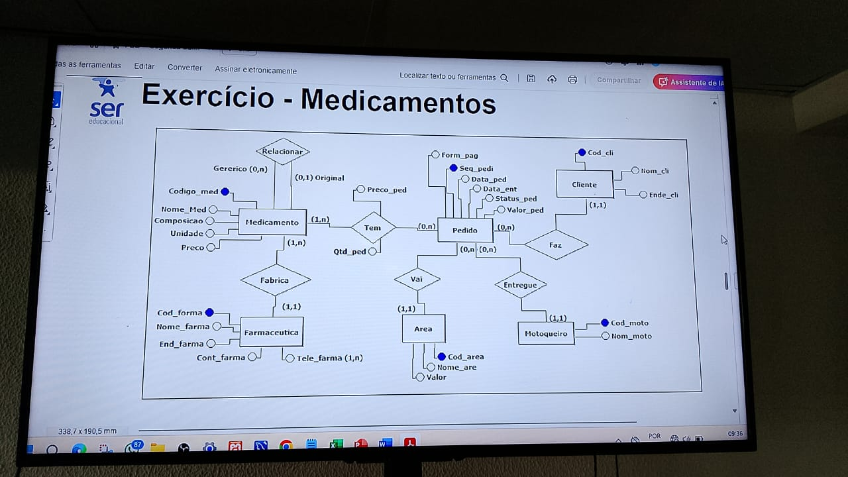Davi Ramos Ferreira – 01702924 – 3MC

CREATE DATABASE MedicamentosDB;

USE MedicamentosDB;

CREATE TABLE Cliente (

Cod_cli INT PRIMARY KEY,

Nom_cli VARCHAR(255),

Ende_cli VARCHAR(255)

);

CREATE TABLE Motoqueiro (

Cod_moto INT PRIMARY KEY,

Nom_moto VARCHAR(255)

);

CREATE TABLE Area (

Cod_area INT PRIMARY KEY,

Nome_are VARCHAR(255),

Valor DECIMAL(10,2)

);

CREATE TABLE Farmaceutica (

Cod_forma INT PRIMARY KEY,

Nome_farma VARCHAR(255),

End_farma VARCHAR(255),

Cont_farma VARCHAR(20),

Tele_farna VARCHAR(20)

);

CREATE TABLE Medicamento (

Codigo_med INT PRIMARY KEY,

Nome_Med VARCHAR(255),

Composicao TEXT,

Unidade VARCHAR(50),

Preco DECIMAL(10,2),

Generico BOOLEAN,

Original BOOLEAN

);

CREATE TABLE Fabrica (

Codigo_med INT,

Cod_forma INT,

PRIMARY KEY (Codigo_med, Cod_forma),

FOREIGN KEY (Codigo_med) REFERENCES Medicamento(Codigo_med),

FOREIGN KEY (Cod_forma) REFERENCES Farmaceutica(Cod_forma)

);

CREATE TABLE Pedido (

Seq_pedi INT PRIMARY KEY,

Data_ped DATE,

Data_ent DATE,

Status_ped VARCHAR(50),

Valor_ped DECIMAL(10,2),

Form_pag VARCHAR(50),

Cod_cli INT,

FOREIGN KEY (Cod_cli) REFERENCES Cliente(Cod_cli)

);

CREATE TABLE Pedido_Medicamento (

Seq_pedi INT,

Codigo_med INT,

Qtd_ped INT,

Preco_ped DECIMAL(10,2),

PRIMARY KEY (Seq_pedi, Codigo_med),

FOREIGN KEY (Seq_pedi) REFERENCES Pedido(Seq_pedi),

FOREIGN KEY (Codigo_med) REFERENCES Medicamento(Codigo_med)

);

CREATE TABLE Pedido_Area (

Seq_pedi INT,

Cod_area INT,

PRIMARY KEY (Seq_pedi, Cod_area),

FOREIGN KEY (Seq_pedi) REFERENCES Pedido(Seq_pedi),

FOREIGN KEY (Cod_area) REFERENCES Area(Cod_area)

);

CREATE TABLE Pedido_Entrega (

Seq_pedi INT,

Cod_moto INT,

PRIMARY KEY (Seq_pedi, Cod_moto),

FOREIGN KEY (Seq_pedi) REFERENCES Pedido(Seq_pedi),

FOREIGN KEY (Cod_moto) REFERENCES Motoqueiro(Cod_moto)

);